Before and after

SELECT lotterywinnerfinderx(17, 'Atlanta Hawks', 1, 1, 1);

-- 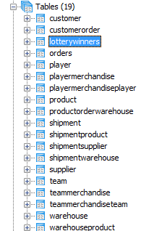demonstrating that this procedure will create a table if it doesn’t already exist.

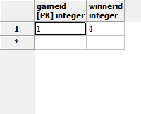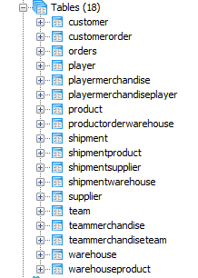

SELECT lotterywinnerfinderx(17, 'Atlanta Hawks', 2, 1, 2);

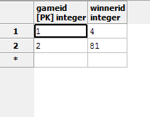

SELECT lotterywinnerfinderx(17, 'Atlanta Hawks', 2, 1, 3);

-- demonstrating that the randomness of the draw comes from the random number given to the program (in this case: 2), rather than from the stored procedure itself.

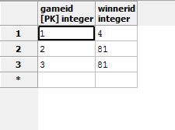

SELECT lotterywinnerfinderx(0, 'Atlanta Hawks', 2, 1, 4);

-- in our database, there have been no purchases for products related to player 0 on the Atlanta Hawks, so the threshold was not met, so there was no draw. Therefore there is no winner and so the winnerid record for game 4 is NULL.

